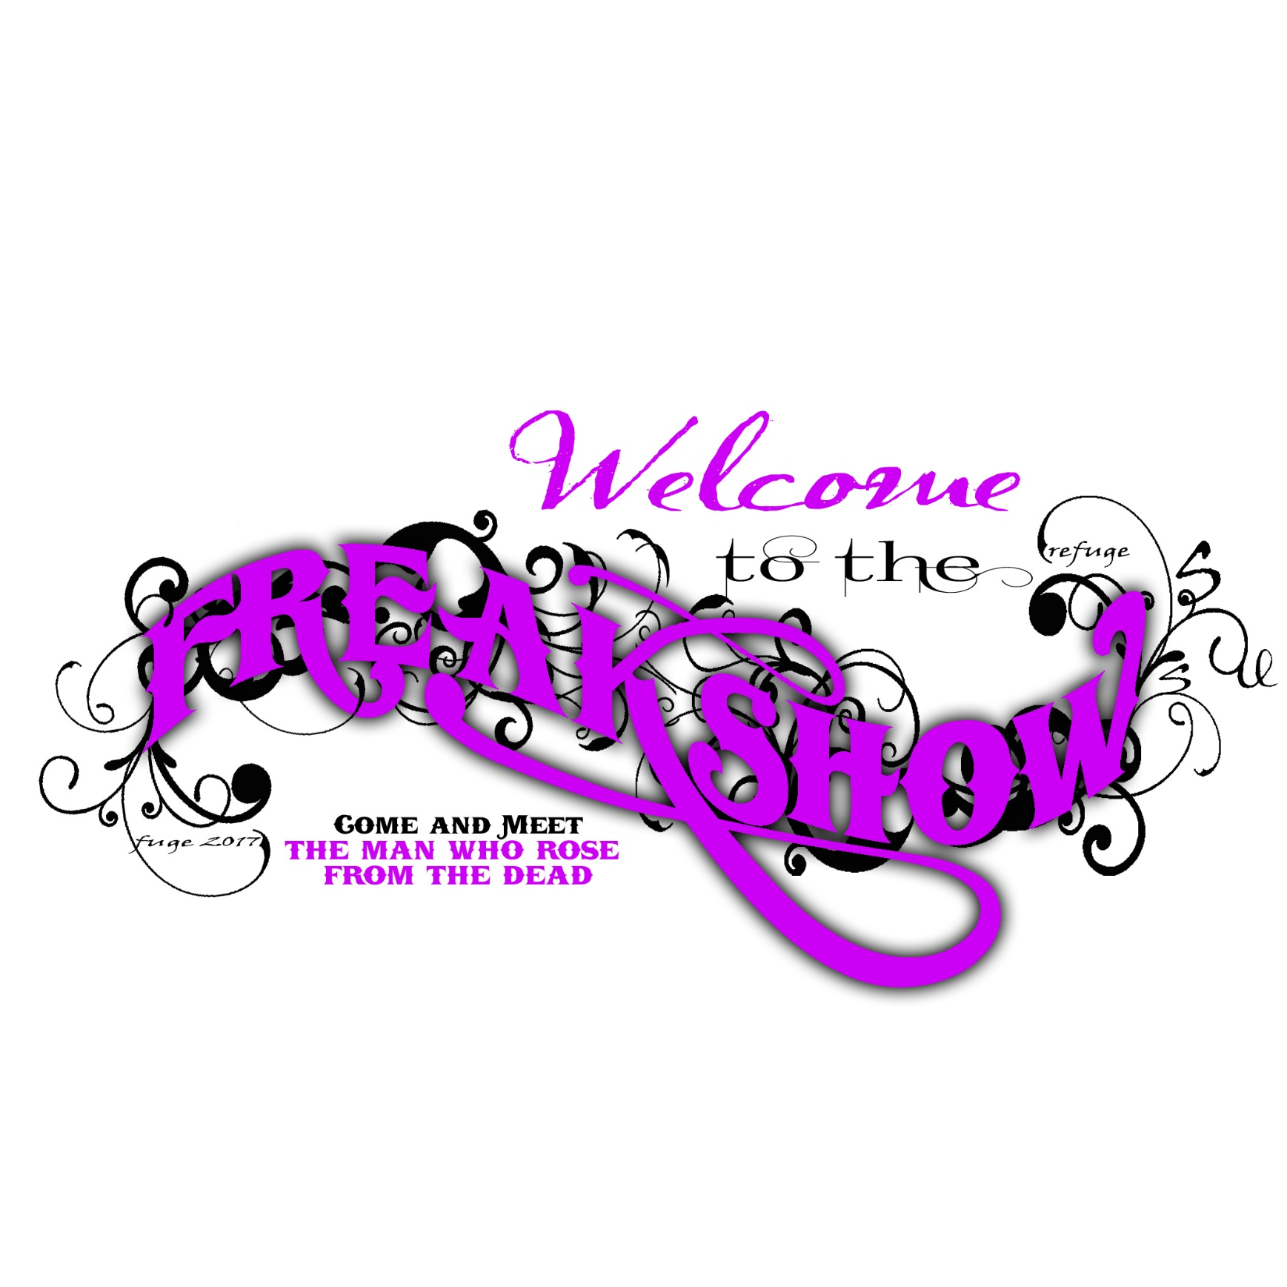

SUMMER CALENDAR



**FOCUS Sports Camp – June 5th to June 9th**

Wednesday, June 7th – San Marcos River and Service Day

**HANGTIME** June 4th End of the School Party

June 30th Movie Day

Hangtime is a time of relaxing and building relationships. Hangtime is generally the first Sunday of every month.

**BIG TIME** June 13th Capture the Flag

June 27th Fuge After Party

Big Time is the Tuesday night bible study and social time throughout the summer. We will be studying Victory over the Darkness starting at 6 pm and then have a time of fun starting at 7:30 pm. Come be a part of both bible study and fun time.

**FUGE TENNESSEE – June 18th to June 25th**

**DIG DEEP 1 Thessalonians Study**

June 4th, June 11th, June 27th

Dig Deep is a high school bible study for those that hope to dig deeper into the word of God with daily work at home. We will be doing a Precept Study on 1 Thessalonians. **Cost $10** which will help provide for lunch after 3rd service.

**SUMMERLIFE** June 7th FOCUS Prayer Time

June 14th Game Night

June 21st FUGE Prayer Time

June 28th Wedding Renewal

Summerlife is a church wide time of worship and bible study. We will have youth bible study during these nights as well.



**ROMANIA MISSION TRIP – July 7th to July 19th**

**BIG TIME** July 4th Fireworks

July 25th Karaoke Dance Party

Big Time is the Tuesday night bible study and social time throughout the summer. We will be studying Victory over the Darkness starting at 6 pm and then have a time of fun starting at 7:30 pm. Come be a part of both bible study and fun time.

**Schlitterbahn July 25th Cost: $50 9 am to 10 pm**

We will be taking a trip to New Braunfels to visit the waterpark Schlitterbahn. Bring money for dinner.

**DIG DEEP 1 Thessalonians Study**

July 2nd July 9th July 23rd July 30th

**SUMMERLIFE** July 5th 70’s Decade Night

July 12th 80’s Decade Night

July 19st 90’s Decade Night

July 26th 00’s Decade Night



**BIG TIME** August 1st Strategy Game Night

August 8th Hunger Games

August 15th Board Game Night

Big Time is the Tuesday night bible study and social time throughout the summer.

**REFUGELIFE** August 2nd Sharing the Gospel

August 9th Living Evangelism

August 16th Mission Life

Refugelife is the early version of refuge with a focus on teaching some of the essential parts of faith in Jesus. How to share your faith, evangelism and missions.

**HANGTIME – TENOG 5 pm to midnight Cost:$30**

We will be bringing back The Epic Night Of Games. Jumpoline Park, Bowling, Laser Tag. It will be an epic night!

**DIRT 2.0 Cost:$65**

DIRT at Twin Oaks Ranch is back in August. We will be ready to start the year with a fun retreat studying the word of God and celebrating Him.

**DIG DEEP 1 Thessalonians Study**

August 6th, August 13th, August 20th, August 27th

**Refuge begins August 30th**